

ISLAND HALL

TECHNICAL INFORMATION

Lagan Valley Island, The Island, Lisburn, BT27 4RL
Telephone: 028 9244 7300
A Lisburn & Castlereagh City Council Facility

Updated June 2025

GENERAL

Stage
The performance dimensions are:
▪ 6m deep. Width variable depending on stage drapes up to 13m
▪ Variable height to grid of up to 6.5m

Truss Systems
▪ Please contact the technical team if you are planning to rig lighting, audio visual or any production equipment including backdrops etc. from the Island Hall trusses.
▪ We hold the right not to rig or hang any equipment without prior approval.
▪ All trusses have safe working limits which must be adhered to.
▪ All trusses come into rigging height.

Drapes
1 x Filled cloth cyclorama, 14m x 6m 30cm drop
1 x Border, black wool surge, 12m x 1m drop
1 x Pair of Intermediate tabs, black wool surge, 14m by 6.5m drop
6 x Legs, Black wool surge, 2m by 6.5m drop
1 x Pair Front Tabs, velour 16m x 6.5m drop
1 x Front pelmet, velour 16m x 1m drop
2 x Side masking velour 2m x 7.5m drop

Curtain Tracks
2 x 14m, rope operated, overlap.
1 x 14m walk along.

Orchestra Pit
5 x Microphone Sockets
1 x Talkback Outlets

Floor
▪ Stage Floor is Black Rosco Dance Floor 16m by 7.5m..
▪ You may not screw any material to the floor.

Dressing Room Facilities
▪ 2 Dressing rooms with showers and disabled toilets (12 max per room)
▪ Green Room/Changing Space.

Mains Supply
▪ ‘C’ form 63 amp 3-phase supply upstage left.
▪ ‘C’ form 32 amp single phase supply downstage left and right.
▪ Various 13 amp sockets around stage area.

Lecterns
2 x Steel lecterns with built in microphone on request.

LIGHTING (15 amp house)
(Lighting plan at the end of this document)

LX bars on Stage Truss
2 x 12m, 12 socket lighting barrels comprising 24 single dimmer circuits and 6 paired circuits on upstage bar.

LX bar on Orchestra Pit Truss
2 x 6 way barrels with individual circuits.

LX bar on FOH Truss
1 x 14m 12 way barrel with individual circuits.

Stage Panels
2 x 6 way socket outlet boxes situated SL and SR.

Dimmers
84 x Dimmer circuits installed.

Lighting Console
1 x ETC ION XE 20 with dual Dell touchscreens

Luminaries
10 x 15/32 SL zoom profiles
6 x 25/50 SL zoom profiles
12 x Cantata Fresnels c/w barn doors
18 x Selecon Rama Fresnels c/w barn doors
8 x Par 64 CP62
6 x Chauvet Rogue R2X Wash Moving Head (FOH)
18 x Elation SIXPAR 200 (LED PAR)
9 x Martin Rush Profile+ Moving Head
4 x CLF ARES XS CYC Flood LED
8 x CLF ARES XS (House LED Flood)

Follow Spots
1 x Chauvet Ovation Sp300 CW

SOUND

Front of House (FOH)
1 x Martin Audio W8LM line array system comprising one W8LMD down-fill and three W8LM boxes a side. One WS 218X sub per side also available.
1 x 32 / 8 multicore available on request.
Processing via
1 x DBX Driverack Venu 360
1 x Martin DX 1

Monitors
2 x Martin Audio F15+ monitors flown in lighting grid.
4 x Martin Audio LE1200 stage monitors *
6 x Martin Audio LE1500 stage monitors *

Sound Console
1 x Yamaha CL5 72 channel digital desk.
1 x Yamaha Rio 3224-D (on stage)
1 x Yamaha Rio 1608-D (on stage)
1 x Yamaha Rio 1608-D (FOH control position)
2 x Yamaha HS5 Studio nearfield monitors (FOH control position)

Microphones
4 x Shure B58 *
4 x Shure B57 *
2 x Shure B87 *
10 x Shure SM58 *
4 x Shure SM57 *
1 x Shure B52 *
1 x Shure B91 *
6 x Sennheiser e904 *
4 x Sennheiser e906 *
2 x Akg C214 *
4 x Akg SE300b CK91 *
2 x Akg SE300b CK93 *
1 x Audio-technica AT8033 *
12 x BSS AR133 active DI box *
6 x LD Systems active DI box *
3 x Sennheiser ME34 Lectern mic *

4 x Sennheiser ew300 G3 Radio transmitters.
4 x Sennheiser ew300 G3 e935 Handheld recievers.
2 x Sennheiser ew300 G3 Headset radio transmitters (strictly for conference use only).

Facilities Panel
2 x facilities panel (one each side of stage):
8 x Microphone Sockets
1 x Talkback outlets
2 x Audio Returns for Foldback

Playback Equipment
1 x Tascam CD player
1 x Tascam CD\MD player
1 x Macbook Pro with Q Lab* (Q Lab programming or any time incurred during set-up will incur an extra charge.
Communications
4 x Headsets for stage to booth communications
1 x Show relay system to dressing rooms, green room and backstage areas, Call mic from Stage Managers desk Stage right

AUDIO VISUAL

Projection
1 x Denon Blu-ray Player
1 x Roland V60HD Vision Mixer
1 x BlackMagicDesigns ATEM mini
1 x 40” Multiview Monitor
1 x Vivitek 8000 Lumens Laser projector
1 x Projection Screen. (9m x 5m)
1 x PTZ Optics PTZ cameras 12x Zoom
1 x PTZ Optics PTZ cameras 30x Zoom
1 x PTZ Optics Fixed camera12x Zoom
3 x HP i7 Laptop (Presentation & Zoom)
2 x BMD SDI splitter (1in 8out)
2 x Bluestream HDMI splitter (1in 4 out)
2 x 24inch HDMI monitors

Use of items marked with an * will incur a separate hire charge (if not included as part of a package). Please refer to the Equipment Hire Listing for charges.

IMPORTANT INFORMATION
PLEASE READ

1. Additional/Touring lighting, sound and any electrical equipment must hold a current Portable Appliance Test (PAT). Proof of PAT must be shown to Lisburn & Castlereagh City Council staff before connection to mains.

2. The venue must be informed of the use of any naked flames, pyrotechnics etc, in advance of arrival. Use of these must form part of your risk assessment.

3. Crew requirements must be requested in advance i.e. no less than six weeks. Lagan Valley Island operates on a one technician basis, working standard hours. Any additional support will be chargeable.

4. LVI Technicians cannot change/adjust clients’ ‘Powerpoint’ presentations.

5. Q Lab programming (if available) will incur an additional charge.

6. Scenery must be flame checked.

7. You may not screw any material into the floor.

8. Painting is not permitted in the venue at any time (i.e. sets etc).

9. If sound/lighting operation is required inside the Island Hall auditorium advance notification must be given. i.e. four weeks prior to your event. This is to facilitate the Box Office and ticketing changes which are necessary.

10. Please enclose running times of your performance including details of any intervals.

Events requiring anything other than basic operation of Lighting, Sound, Audio Visual or Stage Management will require extra technical support. Lagan Valley Island has a list of Casual Technicians and with enough notice extra support may be arranged.

A technician is available to set-up equipment etc. but please note that any requirements must be planned at least six weeks in advance to ensure the best possible service and operation of events.

If you have any queries regarding this specification please contact –

Cathal Magee (Arts and Events Technical Officer)

telephone: 07816671918
email: cathal.magee@lisburncastlereagh.gov.uk or arts.technicians@lisburncastlereagh.gov.uk

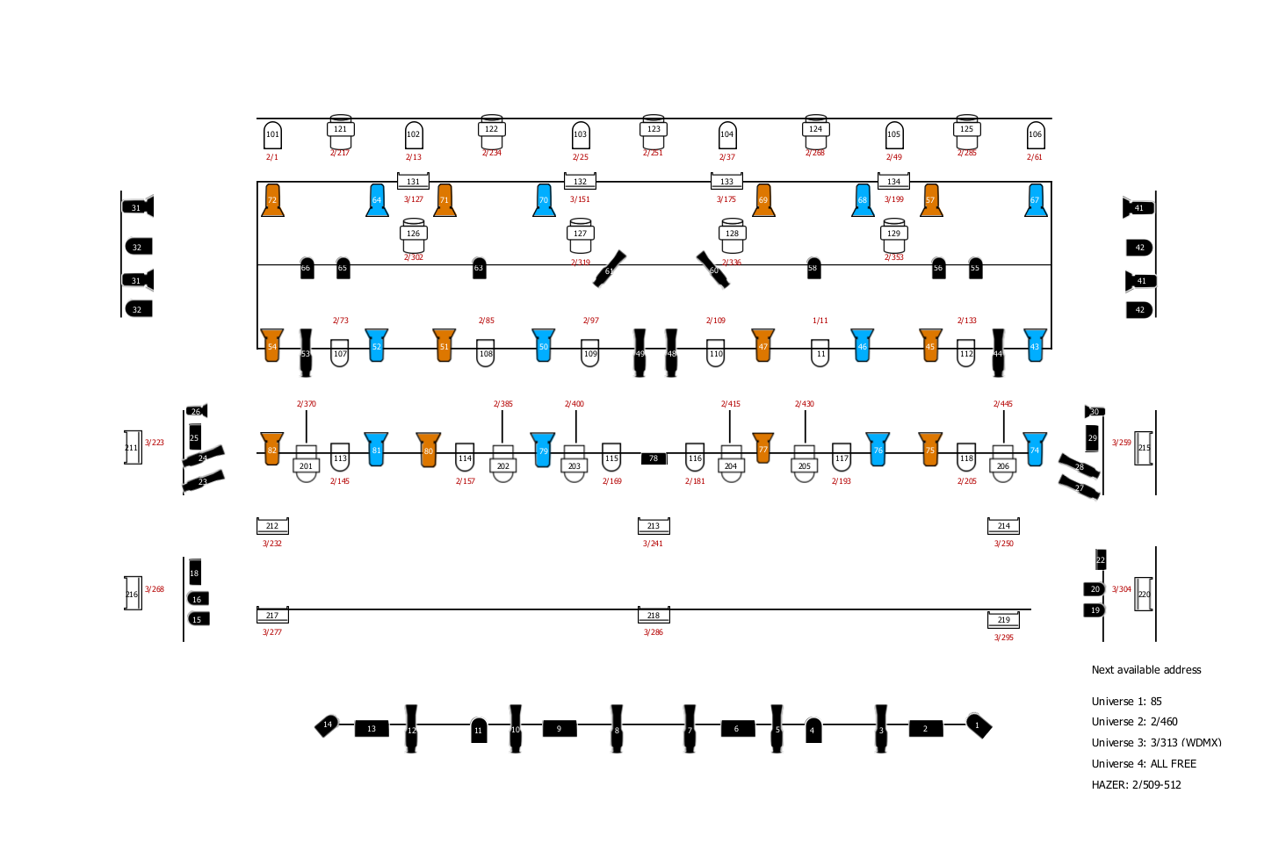
Island Hall Lighting Plan

